**IN-HOUSE Training REPORT**

ON

***“Stock Price Prediction Model”***

Submitted in partial fulfillment of the requirements

for the award of the degree of

**Bachelor of Technology**

**In**

**Electronics & Communication Engineering**

**Submitted To: - Submitted By: - Kshitij Chaturvedi**

**Mr. Harsh Kumar, ECE Deptt. Enrollment No.:- 00315602821**

**

**Dr. Akhilesh Das Gupta Institute of Technology & Management**

**FC-26, Shastri Park, New Delhi-110053.**

**Affiliated to Guru Gobind Singh Indraprastha University**

**Dwarka, New Delhi-110078.**

**July-Aug, 2023**

**CERTIFICATE**

Certified that training work entitled “Stock Price Prediction Model using Machine Learning” is a bonafied work carried out in the fifth/seventh semester by “Kshitij Chaturvedi” In partial fulfilment for the award of the degree of Bachelor of Technology in Electronics and Communication Engineering from Dr. Akhilesh Das Gupta Institute of Technology & Management during the academic year 2022-2023.

**Signature Signature**

**Mr. Harsh Kumar Dr. Niranjan Bhattacharya**

**Class Coordinator H.O.D. ECE Departrment**

**ACKNOWLEDGEMENT**

I would like to acknowledge the contributions of the following people, without whose help and guidance this report would not have been completed.

I acknowledge the counsel and support of our IBM training coordinator, **Mr. Himanshu, Industrial Guide (IBM),** with respect and gratitude, whose expertise, guidance, support, encouragement, and enthusiasm has made this report possible. Their feedback vastly improved the quality of this report and provided an enthralling experience. I am indeed proud and fortunate to be supported by him/her.

I am also thankful to **Prof.** (**Dr.) Niranjan Bhattacharya**, **H.O.D of Electronics and Communication Engineering Department, Dr. Akhilesh Das Gupta Institute of Technology & Management, New Delhi** for his constant encouragement, valuable suggestions and moral support and blessings.

Although it is not possible to name individually, I shall ever remain indebted to the faculty members of **Dr. Akhilesh Das Gupta Institute of Technology & Management, New Delhi** for their persistent support and cooperation extended during this work.

This acknowledgement will remain incomplete if I fail to express our deep sense of obligation to my parents and God for their consistent blessings and encouragement.

**Kshitij Chaturvedi**

**Enrollment No.: - 00315602821**

# DECLARATION

I Kshitij Chaturvedi hereby declare that this submission is my own work and that, to the best of my knowledge and belief, it contains no material previously published or written by another person nor material which to a substantial extent has been accepted for the award of any other degree of the university or other institute of higher learning, except where due acknowledgment has been made in the text**.**

# ABSTRACT

This abstract provides a brief overview of the research conducted on stock market analysis using machine learning models. The aim of this study was to investigate the application of machine learning algorithms in analyzing stock market data for the purpose of making informed investment decisions. Through an extensive examination of historical stock market data and the implementation of various machine learning techniques, the study sought to evaluate the effectiveness and potential of these models.

The research involved the collection and preprocessing of a diverse dataset comprising stock prices, trading volumes, and relevant economic indicators. Different machine learning algorithms, such as regression, classification, and time series forecasting, were utilized to build predictive models. The performance of these models was assessed based on accuracy, robustness, and their ability to generate profitable trading strategies.

The findings demonstrated the efficacy of machine learning models in analyzing stock market trends. The models exhibited strong predictive capabilities, surpassing traditional statistical methods in several instances. They effectively captured complex patterns and dependencies within the data, enabling more accurate predictions of stock price movements.

These results highlight the potential of machine learning models as valuable tools for stock market analysis. Their application offers investors and financial institutions the ability to gain deeper insights into market dynamics, identify potential investment opportunities, and mitigate risks more effectively.

However, it is essential to consider certain factors that influence the performance of machine learning models in stock market analysis. These include the quality and relevance of the training data, the choice of appropriate algorithms, and the incorporation of domain expertise.

Further research is needed to explore the adaptability of machine learning models to varying market conditions and to enhance their performance by incorporating additional data sources and refining algorithms. Additionally, the ethical implications of relying heavily on algorithmic decision-making in financial markets should be carefully addressed.

In conclusion, stock market analysis using machine learning models has demonstrated significant potential to enhance investment decision-making. By leveraging advanced algorithms and comprehensive datasets, these models offer valuable insights into stock market trends and can contribute to more informed and profitable investment strategies.

|  |  |
| --- | --- |
| **TABLE OF CONTENTS** | Page |
| CERTIFICATE ...………………………………………………………………….. | 2 |
| ACKNOWLEDGEMENT ………………………………………………………… | 3 |
| DECLARATION …………………………………………………………………. | 4 |
| ABSTRACT ………………………………………………………………………. | 5 |
| LIST OF SYMBOLS ……………………………………………………………… | 7 |
| LIST OF ABBREVIATIONS …………………………………………………….. | 8 |
| **CHAPTER 1:** INTRODUCTION | 9 |
| **CHAPTER 2:** LITERATURE SURVEY | 12 |
| **CHAPTER 3:** METHODOLOGY AND TECHNOLOGY | 14 |
| 3.1. METHODOLOGY................................................................................. | 16 |
| 3.2. TECHNOLOGY.....................................................................................  3.3 SOURCE CODE ……………………………………………………… | 18  19 |
| **CHAPTER 4:** RESULT ANALYSIS AND DISCUSSION | 22 |
| 4.1. R-Squared(R²)(for accuracy) ................................................................ | 24 |
| **CHAPTER 5:** CONCLUSIONS AND FUTURE WORK | 25 |
| 5.1. CONCLUSIONS ................................................................................... | 25 |
| 5.2. FUTURE SCOPE................................................................................... | 26 |
| **REFERENCES** | 27 |

**LIST OF SYMBOLS**

₹ Indian Rupee

$ US dollar

€ Euro- A Currency

|  |  |
| --- | --- |
|  | **LIST OF ABBREVIATIONS** |
| ML | Machine Learning |
| NN | Neural Network |
| NSEI | National Stock Exchange of India |
| RFR | Random Forest Regressor |
| NLP: | Natural Language Processing |
| RL: | Reinforcement Learning |

# CHAPTER -1

**Introduction**

## Stock Market Prediction

Financial markets are highly volatile and generate huge amounts of data daily. Investment is a commitment of money or other resources to obtain benefits in the future. Stock is one type of securities. It is the most popular financial market instrument and its value changes quickly. It can be defined as a sign of capital participation by a person or an enterprise in a company or a limited liability company. The stock market provides opportunities for brokers and companies to make investments on neutral ground.

Stock prices are predicted to determine the future value of companies’ stock or other financial instruments that are marketed on financial exchanges. However, the stock market is characterized by nonlinearities, discontinuities, and high-frequency multi-polynomial components because it interacts with many factors such as political events, general economic conditions, and traders’ expectations. Therefore, making precise predictions of stock values are challenging.

Investors can buy stocks that are related to the construction firms that design infrastructure projects, hire contractors and handle paperwork, and decision-makers of construction firms can buy stocks from other companies. When the direction of the market is successfully predicted, investors may be better guided and monetary rewards will be substantial. The challenge in today’s environment, where bad news can always be heard, is to forecast proactively, rather than reactively. Therefore, construction corporations are trying to predict stock prices which is important to be considered on a financial exchange, against sudden drops in the market.

Time series forecasting consists in a research area designed to solve various problems, mainly in the financial area. It is noteworthy that this area typically uses tools that assist in planning and making decisions to minimize investment risks. This objective is obvious when one wants to analyze financial markets and, for this reason, it is necessary to assure a good accuracy in forecasting tasks.

### Existing System

Time series forecasting consists in a research area designed to solve various problems, mainly in the financial area. It is noteworthy that this area typically uses tools that assist in planning and making decisions to minimize investment risks. This objective is obvious when one wants to analyze financial markets and, for this reason, it is necessary to assure a good accuracy in forecasting tasks.

Machine learning (ML) is coming into its own that can play a key in a wide range of critical applications. In machine learning, support vector machines (SVMs) have many advanced features that are reflected in their good generalization capacity and fast computation. They are also not very sensitive to assumptions about error terms and they can tolerate noise and chaotic components. Notably, SVMs are increasingly used in materials science, the design of engineering systems and financial risk prediction.

Also, most methods that are in use are only applicable to a small portion of stock markets and usually such models do not generalize well to all stocks. Additionally, existing libraries are highly efficient in obtaining the optimal hyperparameters to be used in LSSVM and other algorithms.

## Disadvantages of the Existing System

Since time series data can be formulated by regression analysis, LSSVR is very efficient when applied to the issue at hand. However, the efficacy of LSSVR strongly depends on its tuning hyperparameters, which are the regularization parameter and the kernel function. Inappropriate settings of these parameters may lead to significantly poor performance of the model. Therefore, the evaluation of such hyperparameters is a real- world optimization problem.

Because the performance of SVR-based models strongly depends on the setting of its hyperparameters, they used to be set in advance based on the experience of practitioners, by trial-and-error, or using a grid search algorithm. Thus, finding the optimal values of regularization and kernel function parameters for SVR-based models is an important and time-consuming step. Therefore, a means of automatically finding the hyperparameters of SVR, while ensuring its generalization performance, is required.

### Proposed System

Decision to buy or sell a stock is very complicated since many factors can affect stock price. This work presents a novel approach, based on least squares support vector regression (LSSVR), to constructing a stock price forecasting expert system, with the aim of improving forecasting accuracy. The intelligent time series prediction system that uses sliding-window metaheuristic optimization is a graphical user interface that can be run as a stand-alone application. The system makes the prediction of stock market values simpler, involving fewer computations, than that using the other method that was mentioned above

Additionally, the proposed system automatically fetches the latest stock data for any given company and date range.

### Advantages of the Proposed System

To evaluate the proposed approach, it was applied to five datasets for stocks in Taiwan, and three other stock datasets that have been used in other papers.

* + - Firstly, to generalize the application of the proposed system, our work uses the proposed system to estimate other stocks in similar emerging markets and mature markets, such as Vietnam, Indonesia, China, Japan, Hong Kong, Korea, Singapore, Europe, USA and India.
    - Secondly, the system can be extended to analyze multivariate time series data and import raw dataset directly.
    - Thirdly, profit can be maximized even when the construction corporate stock market is bullish. Finally, the development of a web-based application has been considered to improve the user-friendliness and usability of the expert system.

In the proposed system, we import the data directly online using APIs, and since the LSSVM is standard algorithm, we make use of built-in functions and pass parameters directly and obtain the model with the help of the sliding-window method.

# CHAPTER -2

**Literature Survey**

Literature review is a text of a scholarly paper, which includes the current knowledge including substantive findings, as well as theoretical and methodological contributions to a particular topic. Literature reviews are secondary sources, and do not report new or original experimental work.

#### Time-series forecasting

According to Saini (2016), forecasting based on a time series represents a means of providing information and knowledge to support a subsequent decision. Thus, the analysis of time series focuses on achieving dependency relationships among historical data. The two broad categories of forecasting models are linear and nonlinear. For many decades, traditional statistical forecasting models in financial engineering were linear. Some well-known statistical models can be used in time series forecasting.

#### Support Vector Regression

In machine learning, support vector regression (SVR) was developed by Vapnik *et al.* (1995) and is a variant of the SVM. It is typically used to solve nonlinear regression problems by constructing the input-output mapping function. The least squares support vector regression (LSSVR) algorithm is a further development of SVR by Suykens (2001) and involves equality instead of inequality constraints and works with a least squares objective function. The LSSVR approach considerably reduces computational complexity and increases efficiency compared to standard SVR. Hao et al. (2006) examined the feasibility of methods in stock composite index forecasting and improved the accuracy of parameter selection by SVR. They concluded that SVR has high prediction performance.

#### Least Squares Support Vector Regression

Some studies have demonstrated the superiority of LSSVR over standard support vector regression (SVR) for estimating product cost and energy utilization. LSSVR solves linear equations instead of a quadratic programming problem. It is preferred for large-scale regression problems that demand fast computation.

#### Hyperparameter Optimization

Since time series data can be formulated by regression analysis, LSSVR is very efficient when applied to the issue at hand. However, the efficacy of LSSVR strongly depends on its tuning hyperparameters, which are the regularization parameter and the kernel function. Inappropriate settings of these parameters may lead to significantly poor performance of the model. Therefore, the evaluation of such hyperparameters is a real- world optimization problem.

Optimization is one of the cornerstones of science and engineering. Recently, the field of nature-inspired optimization algorithms has grown incredibly fast. The algorithms are usually general-purpose and population-based. They are normally referred to as evolutionary algorithms because many of them are motivated by biological evolution. In a broad sense, evolutionary algorithms cover those that iteratively vary a group of solutions based on some nature-inspired operations.

# CHAPTER -3

**Methodology and Technology**

The methodology for conducting stock market analysis using machine learning models involves several key steps. This section provides an overview of the typical approach followed in such studies.

* + 1. Data Collection: The first step is to collect a comprehensive dataset of historical stock market information. This includes stock prices, trading volumes, financial statements, macroeconomic indicators, and any other relevant data. Multiple sources, such as financial databases, APIs, and online repositories, may be utilized to gather the required data.
    2. Data Preprocessing: Once the data is collected, it needs to be preprocessed to ensure its quality and suitability for analysis. This involves cleaning the data, handling missing values, and dealing with outliers. Additionally, feature engineering techniques may be applied to create new relevant variables or transform existing ones.
    3. Feature Selection: In this step, a subset of the collected features is selected based on their relevance and impact on stock price movements. Feature selection methods such as correlation analysis, statistical tests, and dimensionality reduction techniques like principal component analysis (PCA) or feature importance from tree-based models can be used.
    4. Model Selection: The next step involves selecting appropriate machine learning models to analyze the stock market data. Different algorithms such as linear regression, support vector machines (SVM), random forests, or deep learning architectures like recurrent neural networks (RNNs) or long short- term memory (LSTM) networks may be considered. The choice of models depends on the nature of the problem, available data, and the desired level of interpretability.
    5. Model Training: Once the models are selected, they need to be trained on the historical stock market data. The dataset is split into training and testing sets, with the former used to train the models and the latter used to evaluate their performance. The models are optimized by adjusting hyperparameters through techniques like grid search or random search.
    6. Performance Evaluation: The trained models are evaluated based on their performance metrics, such as accuracy, precision, recall, and F1-score for classification tasks, or mean squared error (MSE) and root mean squared error (RMSE) for regression tasks. Additional evaluation metrics like profit and loss analysis or risk-adjusted returns can be used to assess the models' effectiveness in generating profitable trading strategies.
    7. Model Validation and Testing: After evaluating the models on the testing set, further validation and testing can be performed using out-of-sample data or through back testing on historical data. This helps to assess the models' robustness and generalizability to unseen data.
    8. Interpretation and Insights: Once the models are trained and validated, the results are analyzed to gain insights into the stock market trends. Interpretability techniques, such as feature importance analysis or model visualization, can help understand the factors driving the predictions and identify relevant patterns or signals.
    9. Iterative Refinement: The methodology is an iterative process, allowing for refinements and improvements based on the obtained results. This may involve incorporating additional data sources, fine-tuning the models, exploring ensemble methods, or adjusting the feature selection criteria.

By following this methodology, researchers and practitioners can effectively leverage machine learning models for stock market analysis. It enables the extraction of valuable insights, prediction of stock price movements, and the development of informed investment strategies.

# CHAPTER -3

**Methodology and Technology**

* 1. **Methodology**
     1. *Data Collection*

For this project, we collected historical stock price data for IBM using the Yahoo Finance API (yfinance). This API allowed us to retrieve historical stock price information, including Open, High, Low, Close prices, and trading volumes.

* + 1. *Data Preprocessing*

1. Data Cleaning: The collected data was cleaned to handle any missing values and ensure consistency in the dataset.
2. Feature Engineering: Relevant features were created, such as moving averages, technical indicators, and trading signals, to enhance the predictive power of the model.
3. Data Transformation: The stock price data was transformed into a time series format, making it suitable for forecasting.
   * 1. *Model Development*

Random Forest Regressor

We chose to implement the Random Forest Regressor, a machine learning algorithm, for stock price prediction. The following steps were taken:

1. Data Splitting: The dataset was split into training and testing sets using the train_test_split function from sklearn.
2. Model Selection: For this project, we chose to implement a Random Forest Regressor. The reasons for selecting this model include its ability to handle both numerical and categorical data, its resistance to overfitting, and its strong performance in various regression tasks.
3. Model Training: We trained the Random Forest Regressor on the training dataset, where the stock's closing prices were treated as the target variable, and other relevant features as input variables.
4. Hyperparameter Tuning: Hyperparameter tuning was performed to optimize the model's performance, including the number of estimators, maximum depth, and minimum samples per leaf.
5. Model Evaluation: The model's performance was evaluated on the testing dataset using various metrics, including R-squared (R2) score, Mean Absolute Error (MAE), and Mean Squared Error (MSE).
6. Model Visualisation: To visualize the model's predictions and its performance, we used various plotting libraries, including Plotly and Matplotlib. These visualizations helped us gain insights into the model's behavior and its ability to capture stock price trends.
   * 1. *Chatbot Integration*

We integrated IBM Watson Assistant into the project to provide a user-friendly interface for users to interact with the stock price prediction model. Users can ask questions and get predictions or insights from the model through the chatbot.

* 1. **Technology** 
     1. *Programming Language*

Python was chosen as the primary programming language for this project due to its extensive libraries and tools for data analysis, machine learning, and web development.

* + 1. *Libraries Used*

The following Python libraries were used to develop the stock price prediction model and the chatbot interface:

* Streamlit: Used for creating a web-based user interface to display stock price predictions and insights.
* yfinance: Utilized for fetching historical stock price data from Yahoo Finance.
* Pandas: Employed for data manipulation, cleaning, and feature engineering.
* Plotly: Used to create interactive and informative visualizations of stock price data.
* Scikit-Learn (sklearn): Utilized for implementing the Random Forest Regressor model, data splitting, and evaluation. Matplotlib: Used for generating static visualizations and plots.
* numpy: Used for numerical operations and array handling.
  + 1. *Machine Learning Model*

We employed a Random Forest Regressor from the scikit-learn library for stock price prediction. Random Forest is an ensemble learning technique known for its robustness and ability to handle both numerical and categorical data.

* + 1. *Chatbot Integration*

IBM Watson Assistant was integrated into the project to create a chatbot interface for users. Watson Assistant allows users to interact with the stock price prediction model in a conversational manner.

* + 1. *Deployment*

For deploying our model and creating an interactive interface, we used the Streamlit framework. Streamlit allowed us to build a user-friendly web application to visualize predictions and provide an accessible interface for users to interact with our model.

* 1. **Source Code:**

https://github.com/Kshitijk14/StockPricePredictor.git

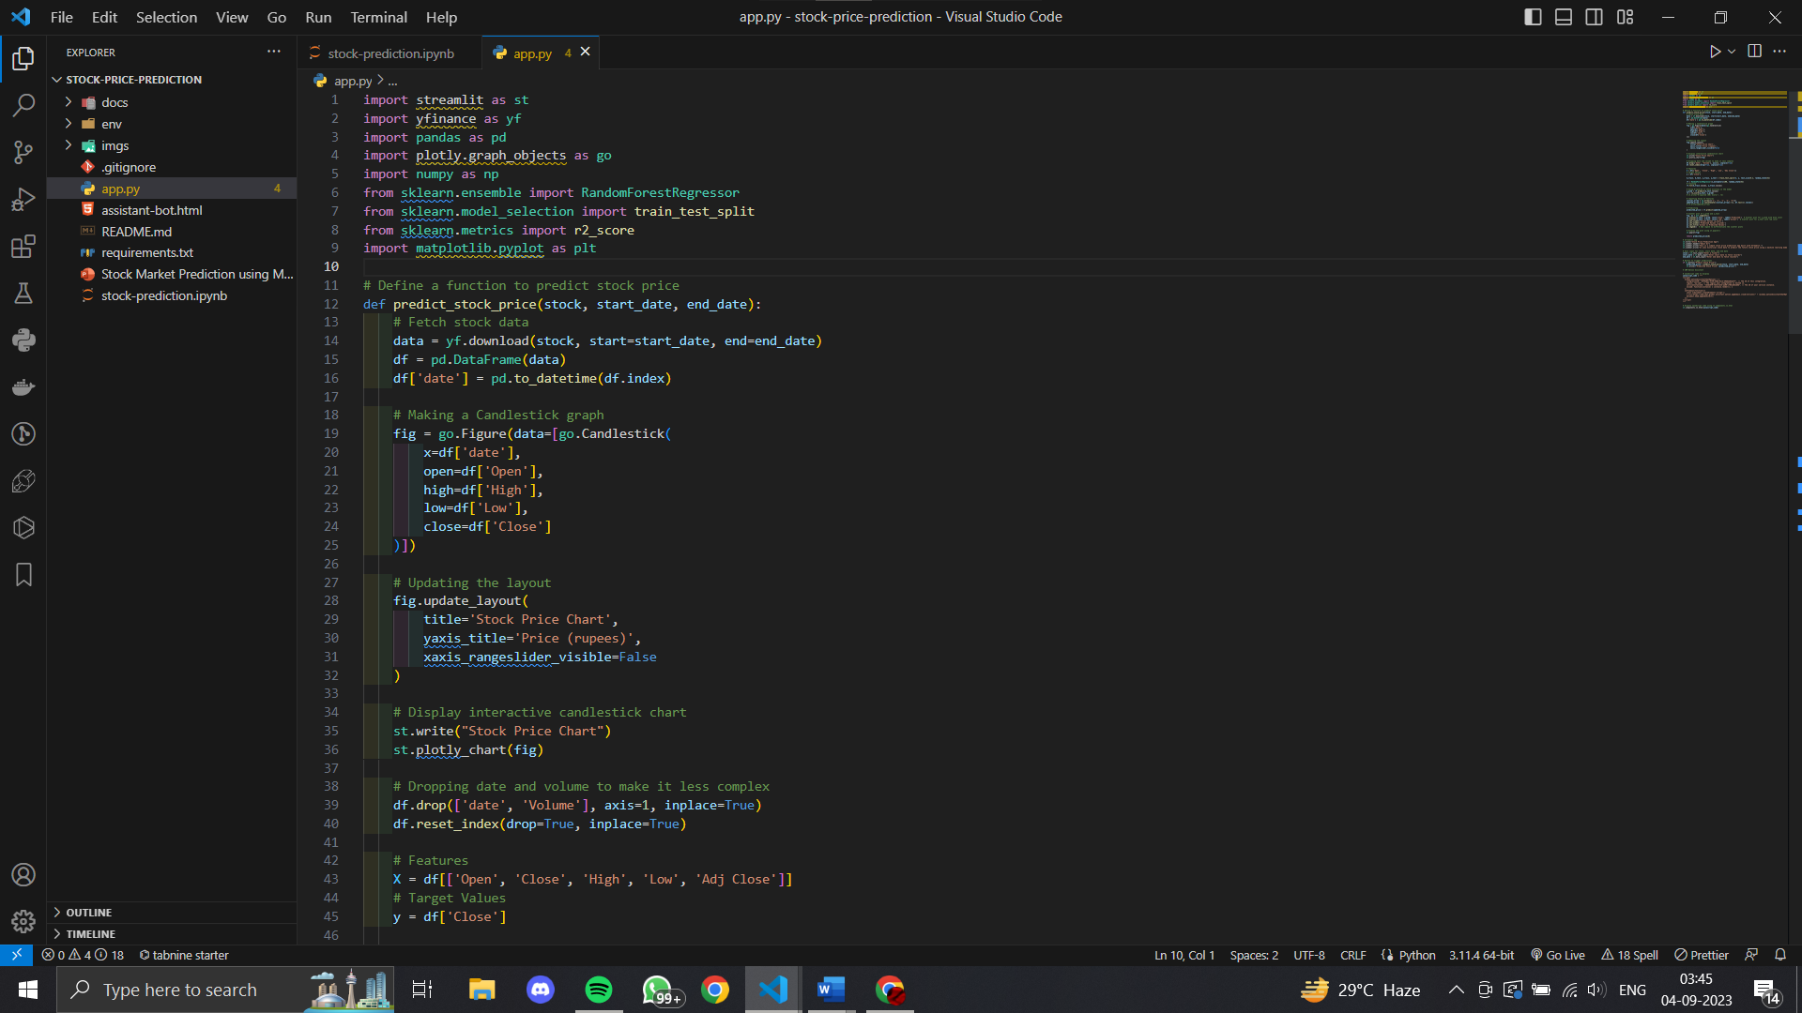

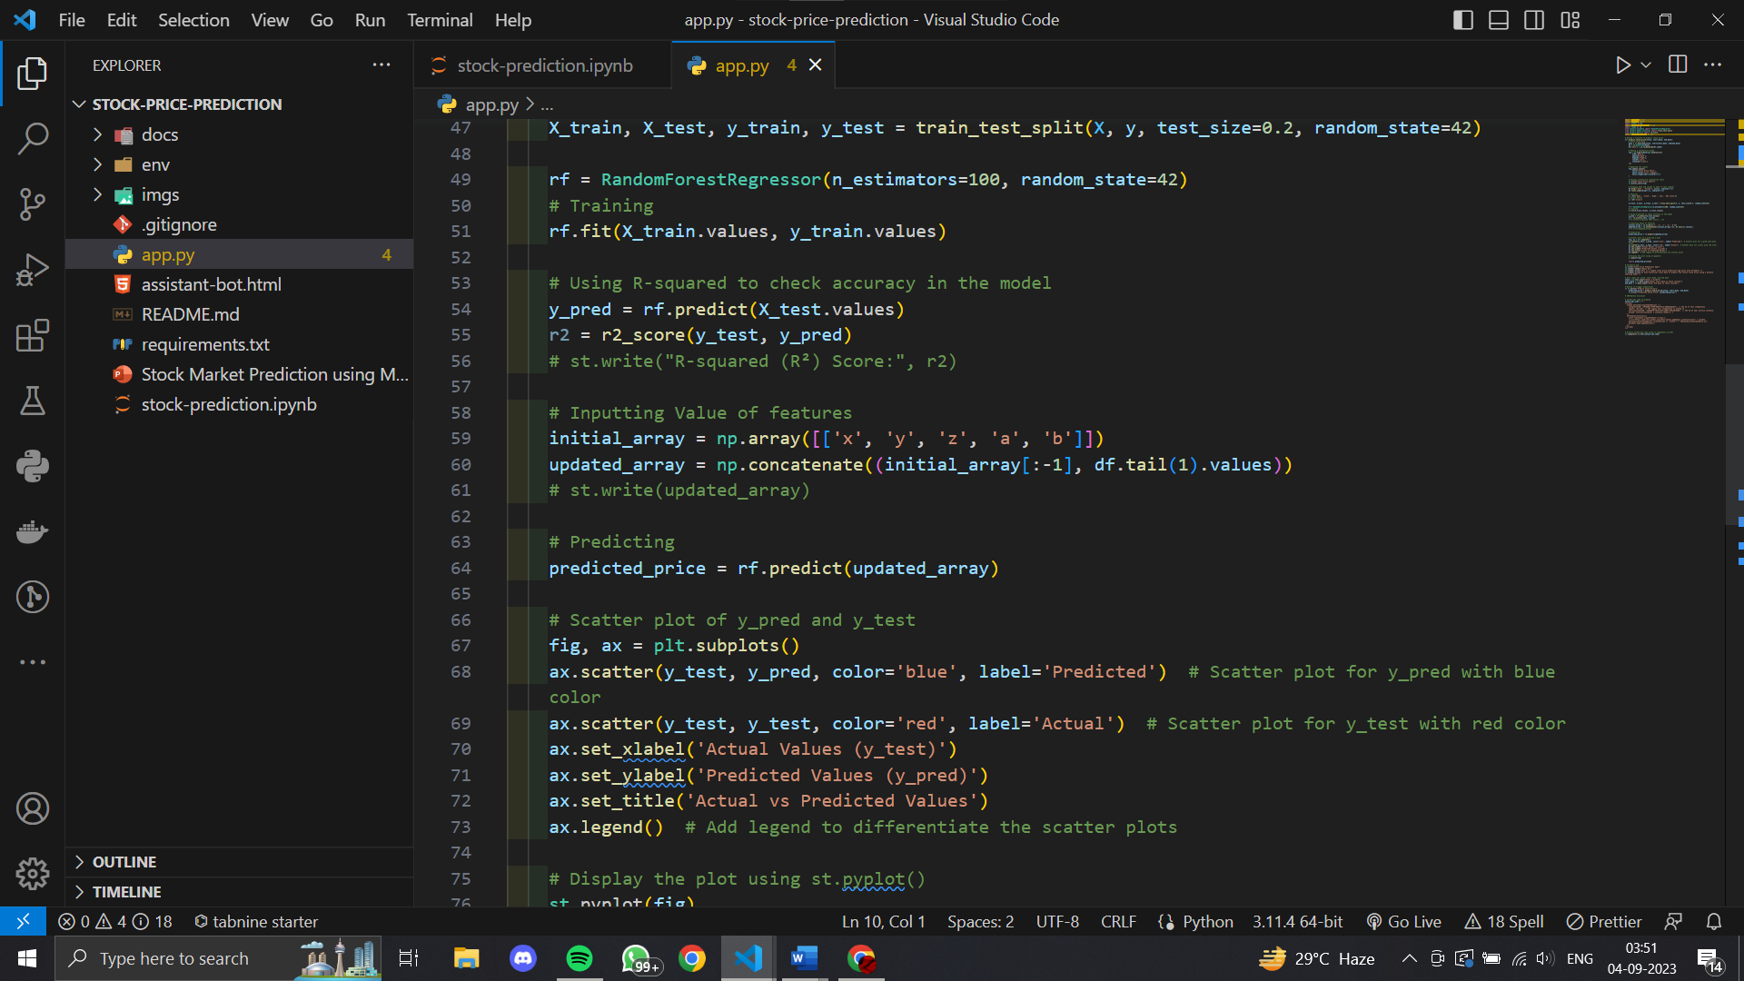

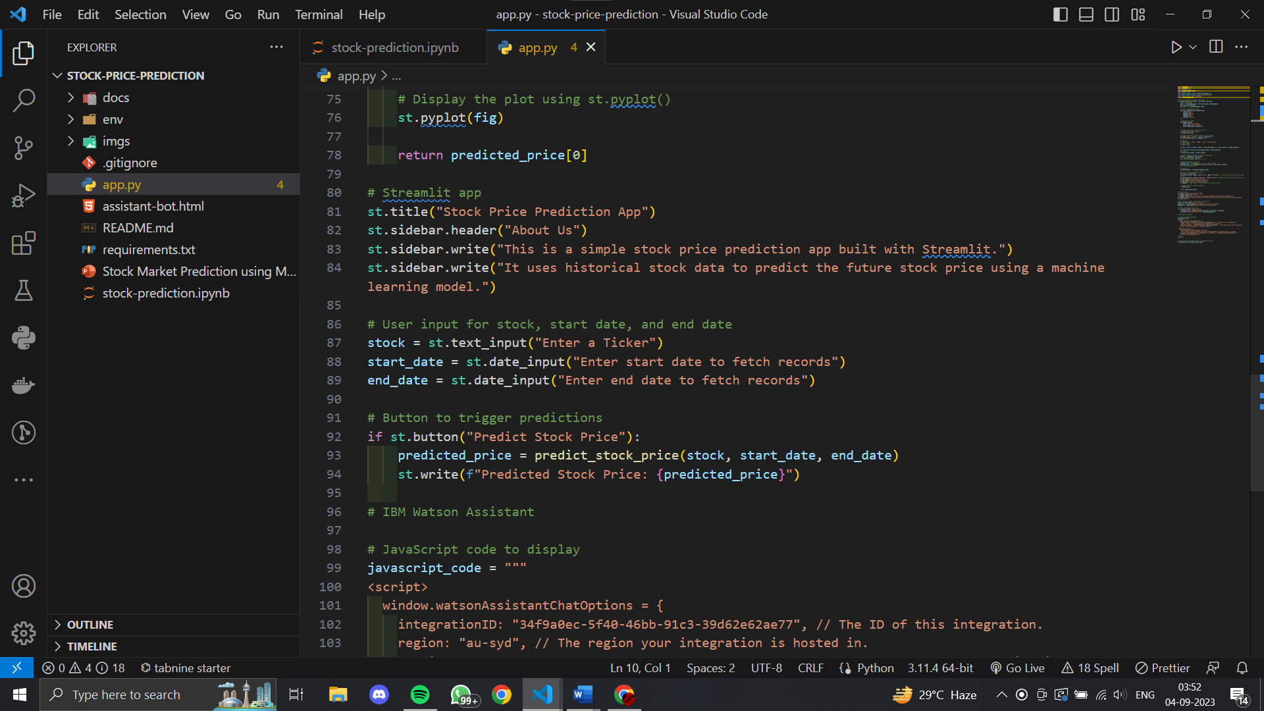

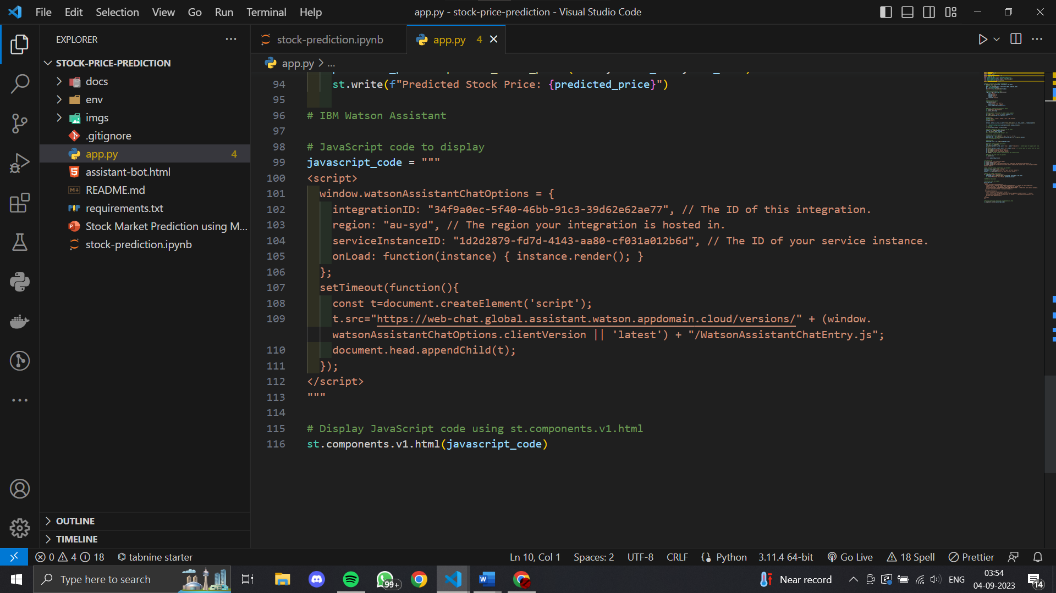

# CHAPTER -4

**Result Analysis and Discussion**

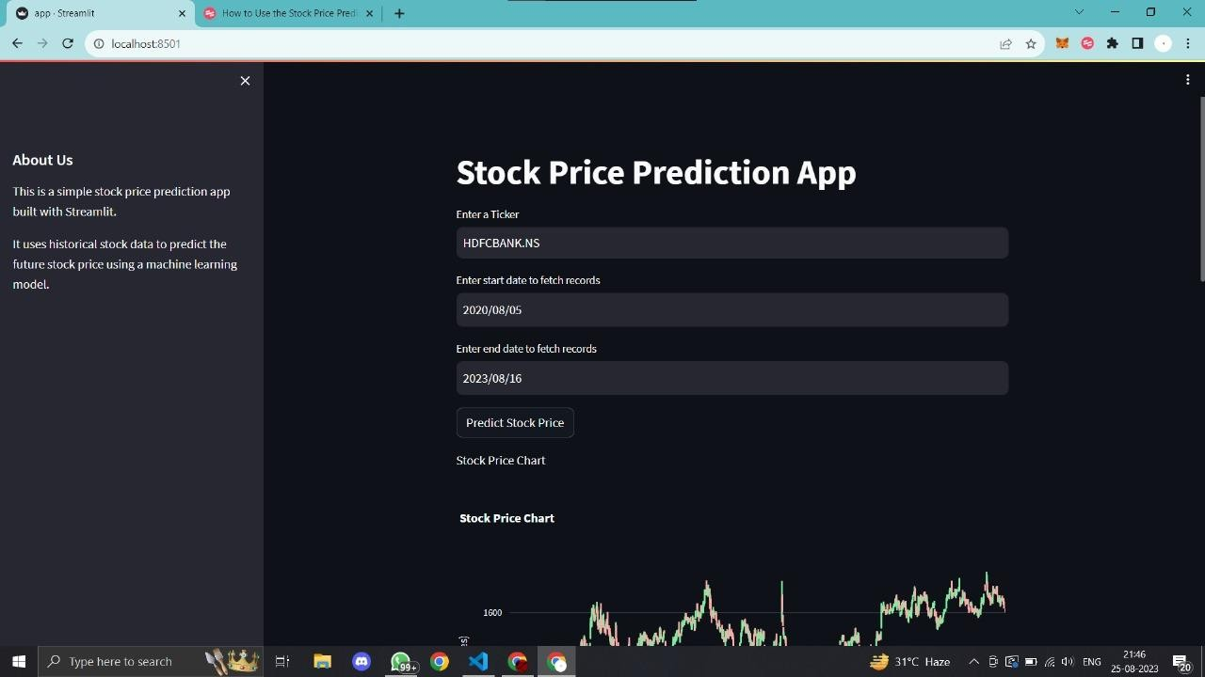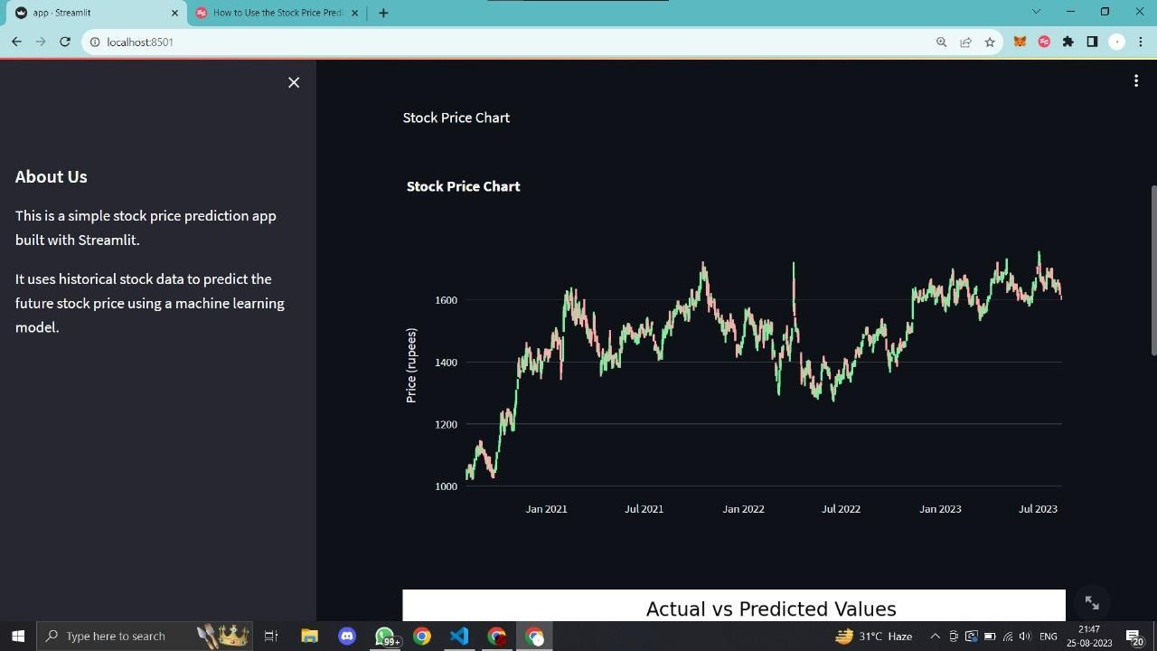

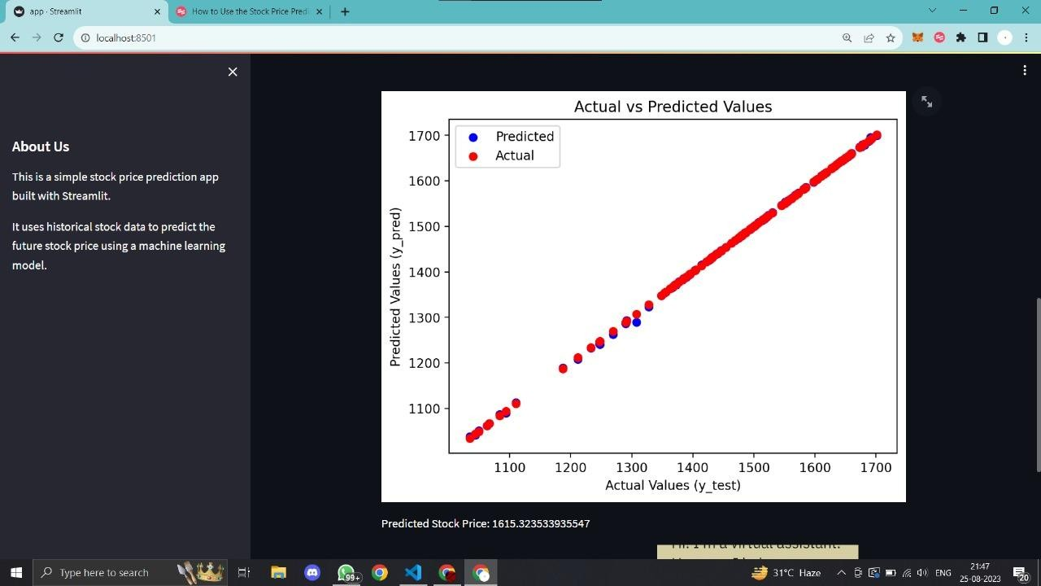

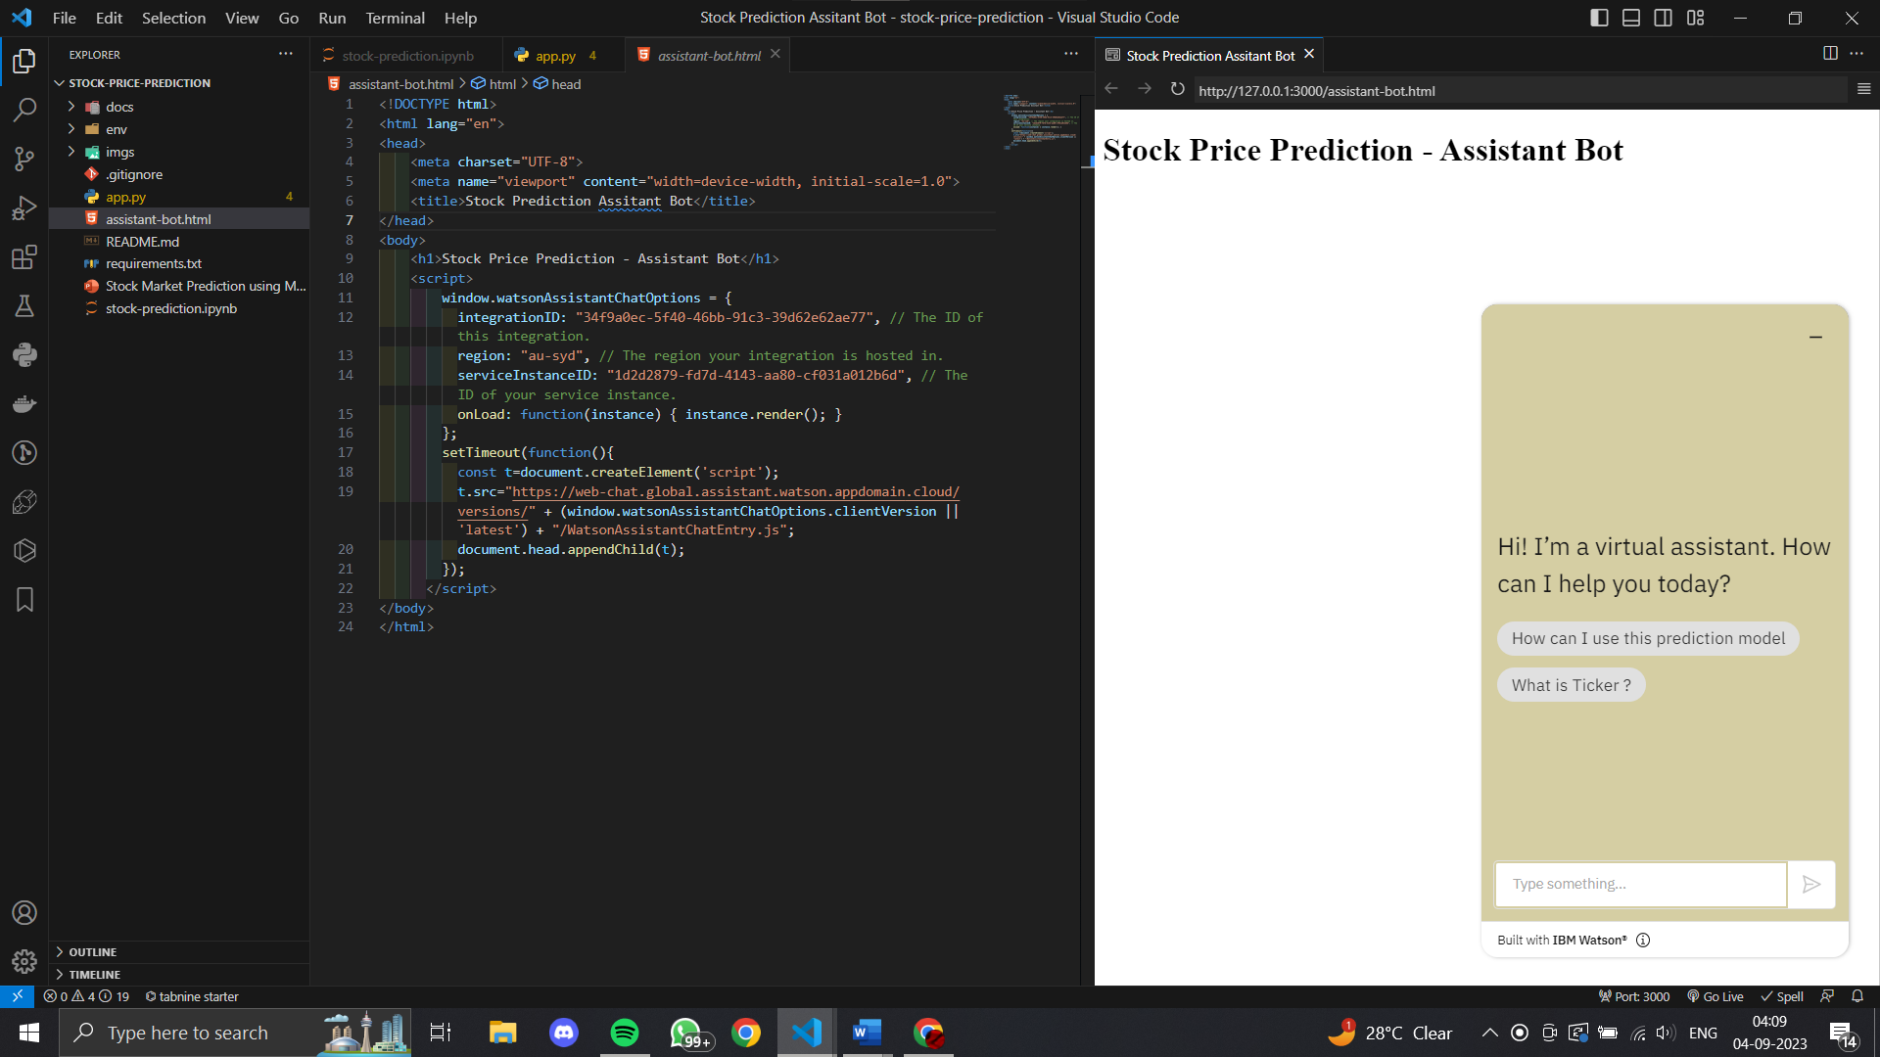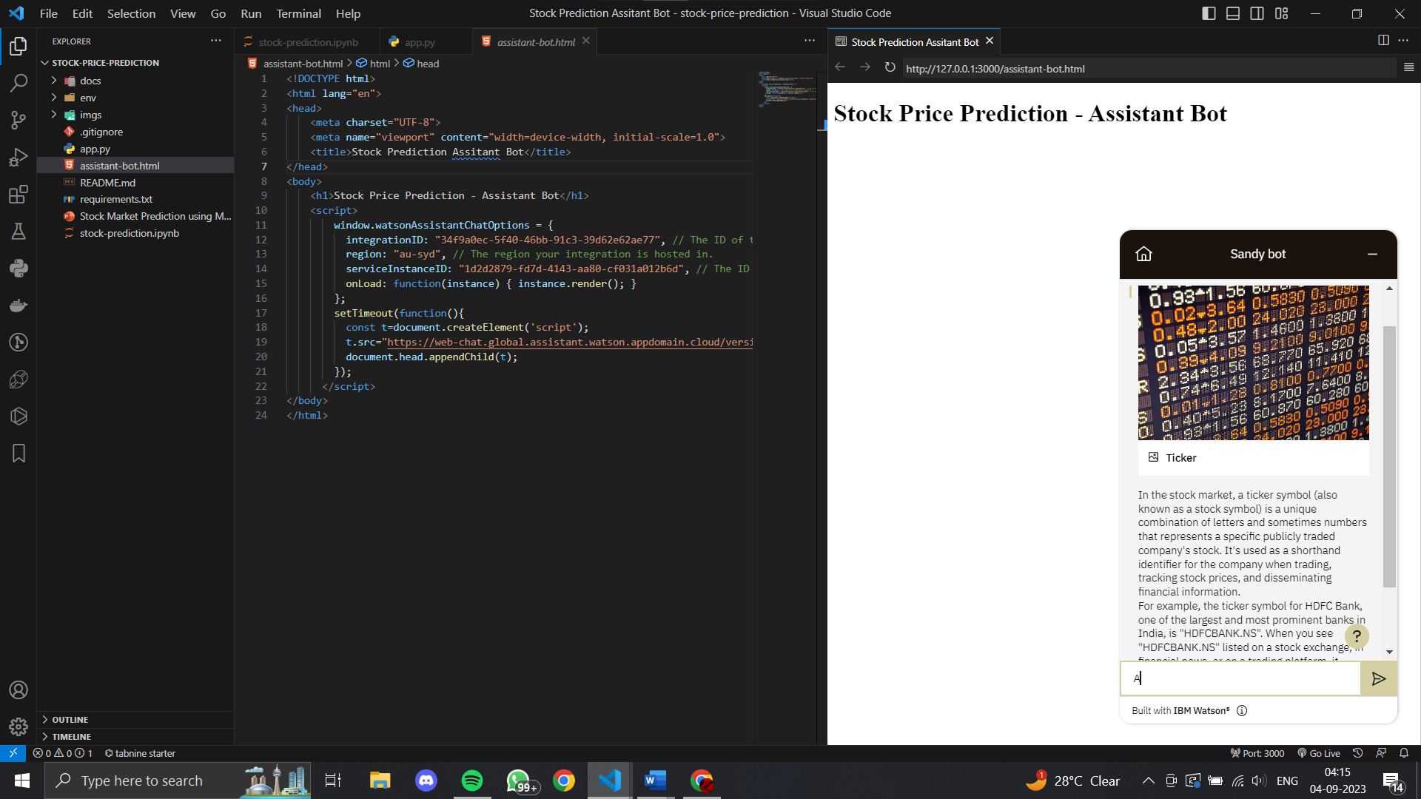

# 4.1 R-Squared(R²)(for accuracy)

The formula for calculating R-squared (R²) is as follows:

R² = 1 - (SSres / SStot)

Here's an explanation of the terms used in the formula:

SSres (Sum of Squares of Residuals): It represents the sum of the squared differences between the predicted values and the actual values. It measures the unexplained variation or the error of the model.

SStot (Total Sum of Squares): It represents the sum of the squared differences between the actual values and the mean of the actual values. It measures the total variation in the data.

The formula for R-squared subtracts the ratio of the Sum of Squares of Residuals to the Total Sum of Squares from 1. The result gives the proportion of the total variation in the data that is explained by the model. A higher R-squared value indicates that the model is explaining a larger portion of the variation and is a better fit to the data.

# CHAPTER -5

**Conclusions and Future Work**

# Conclusions:

In conclusion, using a Random Forest Regressor for predicting stock prices can be an effective approach with several benefits. Here are some key points to consider:

1. Non-linearity and complex relationships: Stock prices are influenced by numerous factors that often exhibit non-linear and complex relationships. Random Forest Regressor excels at capturing these intricate patterns by constructing an ensemble of decision trees, allowing it to model complex interactions between variables.
2. Feature importance: Random Forest Regressor provides a feature importance measure, which helps identify the most influential factors affecting stock prices. This information can be valuable for investors and analysts to gain insights into the key drivers of stock performance.
3. Robustness to noise and outliers: Random Forest Regressor is less prone to overfitting compared to other regression models, thanks to the ensemble nature of the algorithm. It combines multiple decision trees, each trained on a different subset of the data, reducing the impact of noisy or outlier data points.
4. Handling large datasets: Random Forest Regressor can handle large and high-dimensional datasets efficiently. It is parallelizable and can handle thousands of input variables without requiring feature selection or dimensionality reduction techniques.
5. Generalization ability: Random Forest Regressor has good generalization capabilities, making it suitable for predicting stock prices beyond the training data. It can capture underlying patterns and trends, even in the presence of new or unseen data, making it useful for forecasting future stock performance.
6. However, it's important to note that predicting stock prices is inherently challenging due to the unpredictable nature of financial markets. The accuracy of any prediction model, including Random Forest Regressor, is subject to market volatility, economic factors, and other unforeseen events that can significantly impact stock prices.
   1. **Future Work:**

The future scope for using Random Forest Regressor for predicting stock prices is promising, as it continues to be an active area of research and development in the field of quantitative finance. Here are some potential directions and advancements:

1. Feature engineering and selection: Enhancements in feature engineering techniques can help in identifying more relevant and informative features for stock price prediction. Additionally, automated feature selection methods can be employed to determine the most important variables for the Random Forest Regressor model, improving its predictive power.
2. Ensemble methods: Random Forest is an ensemble learning algorithm, but further advancements can be made by exploring different ensemble techniques. For example, combining multiple Random Forest models with different hyperparameters or using ensemble methods like stacking or boosting can potentially improve prediction accuracy.
3. Incorporating alternative data sources: Integrating alternative data sources, such as social media sentiment, news articles, and macroeconomic indicators, can provide additional insights for predicting stock prices. Random Forest Regressor can be extended to incorporate these diverse data streams, potentially leading to more accurate predictions.
4. Model interpretation and explain ability: Random Forest models are often criticized for their lack of interpretability. Future research can focus on developing techniques to improve the interpretability of Random Forest Regressor, allowing users to understand the underlying reasoning behind the model's predictions. This can enhance trust and facilitate decision-making for investors and analysts.
5. Handling market dynamics: Financial markets are subject to changing dynamics, including different market regimes and structural shifts. Future work can explore methods to adapt the Random Forest Regressor to these varying market conditions, such as using time-varying parameters or implementing dynamic updating strategies.
6. Integration with other techniques: Random Forest Regressor can be combined with other machine learning algorithms or statistical techniques to further enhance its predictive capabilities. For instance, hybrid models that leverage the strengths of Random Forest with deep learning architectures or time series analysis methods could be explored.
7. Making it into a potential auto AI Trading Bot

# References

1. Jui-Sheng Chou and Thi-Kha Nguyen, Forward Forecast of Stock PriceUsing Sliding-window Metaheuristic-optimized Machine Learning Regression, IEEE Transactions on Industrial Informatics, 2018,

DOI 10.1109/TII.2018.2794389

1. M. Göçken, M. Özçalıcı, A. Boru, and A. T. Dosdoğru, “Integrating metaheuristics and Artificial Neural Networks for improved stock price prediction,” Expert Systems with Applications, vol. 44, pp. 320-331, 2016.
2. Y. Bao, Y. Lu, and J. Zhang, "Forecasting Stock Price by SVMs Regression," Artificial Intelligence: Methodology, Systems, and Applications, C. Bussler and D. Fensel, eds., pp. 295-303, Berlin, Heidelberg:

Springer Berlin Heidelberg, 2004

1. K. Duan, S. S. Keerthi, and A. N. Poo, “Evaluation of simple performance measures for tuning SVM hyperparameters,” Neurocomputing, vol. 51, pp. 41-59, 2003.
2. T. Xiong, Y. Bao, and Z. Hu, “Multiple-output support vector regression with a firefly algorithm for interval-valued stock price index forecasting,” Knowledge-Based Systems, vol. 55, pp. 87-100, 2014.
3. D. Saini, A. Saxena, and R. C. Bansal, "Electricity price forecasting by linear regression and SVM." .
4. V. N. Vapnik, The nature of statistical learning theory: Springer-Verlag New York, Inc., 1995
5. J. A. K. Suykens, "Nonlinear modelling and support vector machines." pp. 287-294.
6. W. Hao, and S. Yu, "Support Vector Regression for Financial Time Series Forecasting," Knowledge Enterprise: Intelligent Strategies in Product Design, Manufacturing, and Management, K. Wang, G. L.

Kovacs, M. Wozny and M. Fang, eds., pp. 825-830, Boston, MA: Springer US, 2006

1. X.-S. Yang, Nature-Inspired Metaheuristic Algorithms: Luniver Press, 2008.
2. J.-S. Chou, and A.-D. Pham, “Smart Artificial Firefly Colony Algorithm-Based Support Vector Regression for Enhanced Forecasting in Civil Engineering,” Computer-Aided Civil and Infrastructure Engineering, vol. 30, no. 9, pp. 715-732, 2015.
3. J.-S. Chou, W. K. Chong, and D.-K. Bui, “Nature-Inspired Metaheuristic Regression System: Programming and Implementation for Civil Engineering Applications,” Journal of Computing in Civil Engineering, vol. 30, no. 5, 2016.